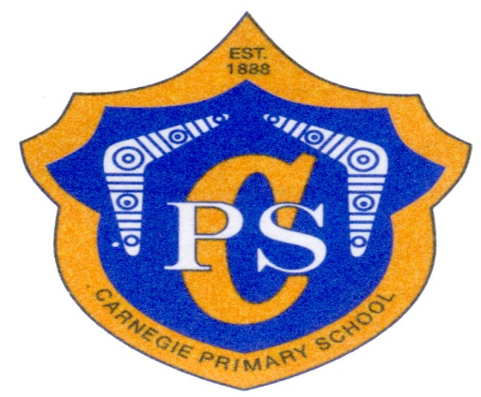

**CARNEGIE PRIMARY SCHOOL INFORMATION BOOK**

|  |  |
| --- | --- |
| stk-fgr5 | 51 Truganini Road  Carnegie 3163  Phone: 03 9571 2662  Email: carnegie.ps@*education*.vic.gov.au  [www.carnegieps.vic.edu.au](http://www.carnegieps.vic.edu.au/) |

|  |  |
| --- | --- |
| C P logo | Location and Contact Details |

|  |  |
| --- | --- |
| School Number | 01-2897 |
| School Address | 51 Truganini Road, Carnegie, 3163 |
| Telephone | 03 9571 2662 |
| Email | carnegie.ps@education.vic.gov.au |
| Website | www.carnegie.ps@vic.edu.au |
| Out of Hours Care | 0402 043 810 |
|  |  |
| Principal | Ms Linda Jones |
| Assistant Principal | Mrs Karen Bentata- Grimm |
| Business Manager  Administration Officers | Mrs Phillipa Sciffer  Ms Annie Easthope &  Miss Molly Wakeham |

##### Term Dates for 2022

**Term 1:** Year 1 to 6 students – Tuesday 1st February to Friday 8th April,2022

Preps – Thursday 3rd February to Friday 8th April, 2022

* *On 3rd & 4th February the Prep students will have a shorter session. Times to be advised in late December*

**Term 2:**  Tuesday 26th April to Friday 24th June, 2022

**Term 3:** Monday 11th July to Friday 16th September**,** 2022

**Term 4:** Monday 3rd October to Tuesday 20th December, 2022

**Prep students don’t attend school on Wednesdays until**

**Wednesday 16th March, 2022**

##### School Values and Philosophy

Carnegie Primary School is committed to providing a safe, supportive and inclusive environment for all students, staff and members of our community. Our school recognises the importance of the partnership between our school and parents and carers to support student learning, engagement and wellbeing. We share a commitment to, and a responsibility for, creating an inclusive and safe school environment for our students. We acknowledges that parents and school staff are strongly motivated to do their best for every child. Everyone has the right to differing opinions and views and to raise concerns, as long as we do this respectfully as a community working together.

**Mission**

We are here to support the academic, social and emotional development of our students to enable them to be resilient to the challenges of a rapidly changing society.

**Vision**

We want to provide an engaging, supportive and inclusive personal learning environment where children can interact positively in a safe, respectful and cooperative atmosphere. We want to challenge students to be reflective and independent learners so they realise their full potential.

**The values of Carnegie Primary School** ‘WELCOMING – ENGAGING – ACHIEVING’ **are demonstrated by the following shared expectations and behaviours:**

**HIGH STANDARDS**

* Inclusive classrooms where we actively participate and strive for personal best
* Provision of relevant, engaging and challenging curriculum that gives students the opportunity to experience success in their learning
* Positive partnerships which engage families and the community in ways that support student achievement and success

**RESPECT**

* We treat others as we would like to be treated
* We work, learn and play in an environment of mutual respect.
* We welcome and value individual and collective diversity
* We play and work safely at all times.

**CARE and RESPONSIBILITY**

* We take responsibility for our own behaviour and understand the logical consequences that follow
* We are responsible for our learning and the learning of others **TE**
* We take time to care for others **AMWORKESPONSIBILITIES**
* We endeavour to be self-motivated learners
* We take care of our own and others personal property and space
* We provide appropriate student services

*At Carnegie Primary School we adhere to the democratic principles asked in Education and Training Reform Act*

##### School Council

The School Council is a representative body which is responsible for developing and implementing the policies of the school. The School Council is comprised of parents, teachers, the principal and community representatives. School councillors nominate for the various sub-committees, which report back to council. The sub-committees are Finance, Buildings and Grounds, Out of School Hours Care, Policy and Programs, Marketing and PFA. The term of office for school councillors is two years with elections held each February / March. The School Council and each subcommittee meets monthly. Membership of the School Council can be rewarding and all parents are encouraged to consider nominating for vacancies.

### Message from the School Council President

*Dear New Parents and Carers,*

*On behalf of the School Council we welcome you and your child. At Carnegie Primary School we pride ourselves on the sense of community that has been cultivated at our school. We encourage an active, positive and rewarding partnership between parents and our staff. We would like you to feel that you can become involved in the school at many different levels such as joining groups or assisting in areas such as:*

* *School Council*
* *Parents and Friends’ Association*
* *social and fundraising events*
* *sports and special events assistance*
* *assisting in classes - reading, typing, perceptual motor program*
* *computer and technological advice*
* *coaching of sport teams*
* *mentoring of students*
* *supporting our library and joining the library lovers group*
* *working bees*

*We look forward to a happy association with your family and trust that the time spent with us will be an enjoyable experience.*

*Yours sincerely,*

*Susan Harper*

*SCHOOL COUNCIL PRESIDENT*

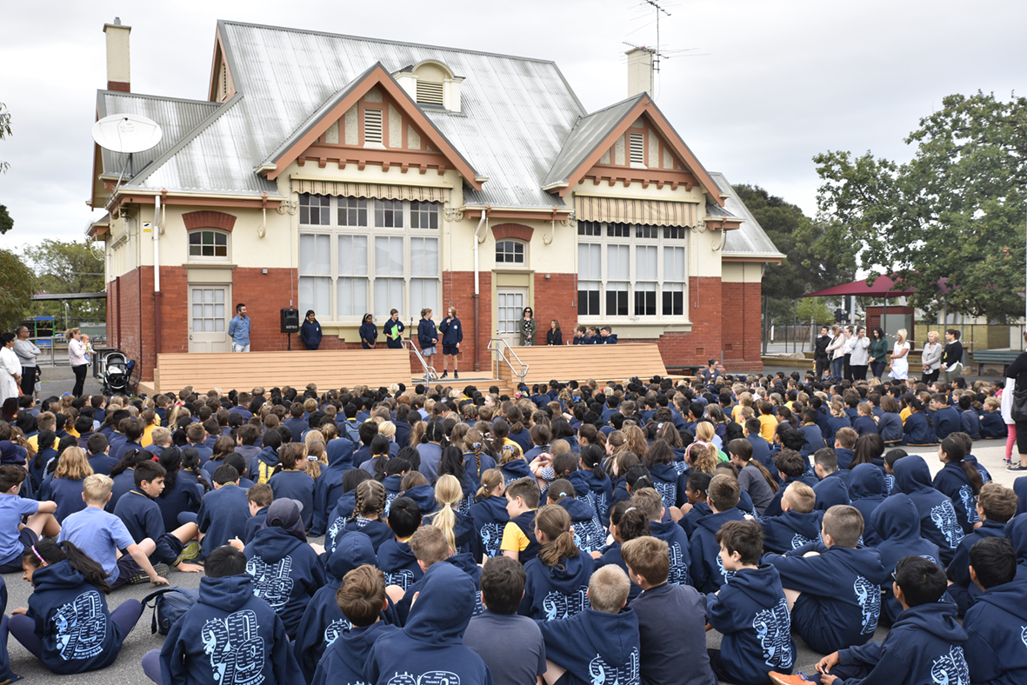

##### Parents and Friends Association

The Parents & Friends’ Association (PFA) was formed to enable parents and friends of students at the school to play an active role in their children’s education and in school events. It is a vital part of the school community and represents our families at the school.

The objective of the PFA is to raise funds for the benefit of the children and the school. Members meet on a monthly basis to discuss ideas for fund raising activities and to plan social events. The Association is an active one and the school community generously supports our activities, resulting in a substantial contribution to the school. Recent fundraising activities have targeted the Audio Visual systems in our new gymnasium, literacy resources, classroom furniture, outdoor landscaping and playground improvements.

The members are a friendly group and enjoy many social functions together. It is a great way to meet new people and to enjoy the company of friends whilst helping the school. We understand that everyone’s lives are busy and appreciate whatever time members are able to offer to the school.

Some of the social, fundraising and community activities of the Parents and Friends’ Association from previous years are:

* welcoming new parents during prep orientation and at our annual School Expo
* welcoming prep families at the first social occasions such as the prep picnic
* Easter Egg Raffle & Hot Cross Bun Drive
* fete and trivia nights
* Mother’s Day & Father’s Day stalls for the children
* crazy hair walkathons
* community BBQs
* end of year school picnic
* working bees
* occasional popcorn and ice-cream sales to students

##### School Accountability

The school’s goals and priorities are set out in a document called the School Strategic Plan. This plan organises school directions into three focus areas - Student Learning, Student Wellbeing and Engagement and Student Achievement - data, opinion surveys and educational research inform the development of this plan.

An ***Annual Implementation Plan*** is developed to:

* Communicate our work for the coming year and how this will lead to achieving the goals and targets in the school strategic plan.
* Ensure efficient and effective allocation of resources to complete the work.
* Monitor progress and success.

An Annual Report is written and an Annual Reporting Night is held to inform the community of our progress towards the goals and targets of our Strategic Plan. All these documents can be found on the school’s website [www.carnegieps.vic.edu.au](http://www.carnegieps.vic.edu.au)

##### School Profile

Our main aim is to foster in students, qualities and skills which will enable them to be successful, confident and tolerant individuals, able to contribute positively to a constantly changing society.

Carnegie Primary offers a comprehensive curriculum in line with the Victorian Curriculum. We strongly emphasis the development of skills in English and Mathematics. Specialist programs are offered in the Arts, Physical Education, ICT and a language other than English, Japanese, with a perceptual motor program (PMP) provided in prep and grade one. We embrace a Discovery Learning model ensuring essential learnings contained in the Victorian Curriculum are covered in a student’s journey at CPS.

To actively support these curriculum areas, the following enrichment programs are provided:

* biennial art exhibitions and whole school concerts
* coding and robotics
* social emotional learning framework that includes Bounce Back, RRRR and other programs
* water safety and swimming lessons
* camps
* interschool sport
* junior school council
* student leadership programs
* buddy program
* instrumental music lessons from external providers (piano, keyboard, guitar and violin)

The school’s grounds consist of a large oval, sandpits, a basketball and netball court as well as shaded fixed play equipment. In 2018 we embarked upon a capital works program funded by the State Government, to construct a gymnasium, art room and music facility. This building opened in late 2018 and the next step of upgrading and refurbishing the existing prep building began. This was completed at the start of 2019, enabling the 2019 prep students to be the first cohort to use the new facilities. We are excited to have the opportunity to considerably enhance our teaching and learning spaces to support 21st century learning and our teaching and learning pedagogy. What exciting times lie ahead!

To facilitate improved student learning outcomes, the school has identified three major student learning goals:

* To maximise learning growth in literacy and numeracy for all students
* To empower all students to be motivated, curious and self-directed learners
* To foster an inclusive and respectful community

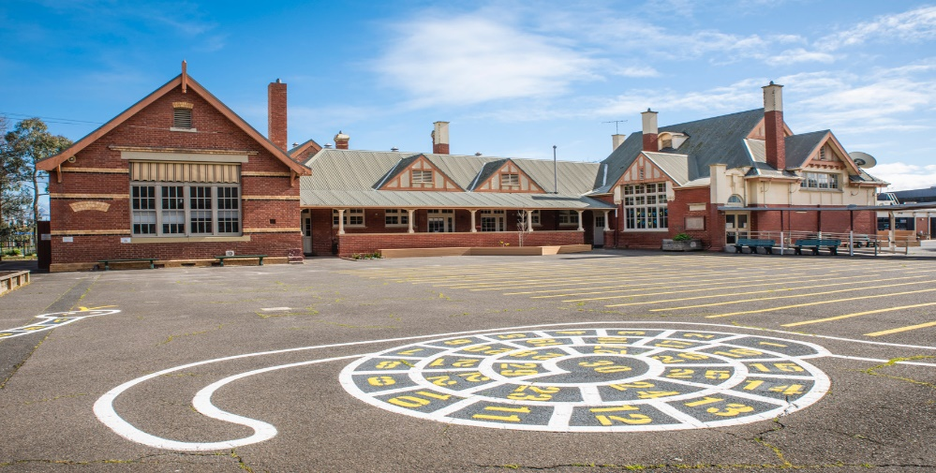

##### School Programs

### **Curriculum**

At CPS we embrace a comprehensive curriculum with a strong emphasis on academic development along with social, emotional and physical development.

The Victorian Curriculum is based on eight learning areas and four general capabilities.

The Learning Areas are: English, Mathematics, Science, Health & PE, Languages, The Humanities, The Arts and Technologies.

The Capabilities are: Critical and Creative Thinking, Intercultural Capability, Personal and Social Capability and Ethical Capability.

More detailed information is available at: <http://victoriancurriculum.vcaa.vic.edu.au/>

### **Music**

* Visiting instrumental teachers in keyboard, strings, piano and guitar for students in year 2 and beyond
* Opportunity for performances at assembly and concerts, fetes, kindergarten visits
* Part-time specialist music teacher
* Biennial school concerts
* School choirs
* Whole school concerts

### **The Arts**

* Specialist Visual and Performing Arts teacher for Years Prep-6
* Purpose built well-equipped Arts room
* Opportunity for performance at assembly and concerts
* Biennial Art Exhibition comprising of student art work from all students

### **Digital Technologies**

* Full time specialist ICT teacher teaching all classes computer skills, coding etc.
* Fully equipped computer room with interactive whiteboard, notebooks and iPads in all classrooms.
* Cyber safety programs

### **Physical Education**

* Comprehensive physical education program for Years Prep-6
* PMP (Perceptual Motor Program) for preps
* Interschool team sports Years 5-6: netball, basketball, football, soccer, softball, volley stars
* Interschool swimming, athletics and cross country carnivals Years 3 - 6
* Intensive swimming program for all children
* Year 3-6 Swimming and Athletics carnivals
* Prep to 2 Athletics Fun Day

### **Language Other Than English – Japanese**

* Japanese Language program Years Prep-6

### **Library**

* Weekly library sessions for all students
* School library providing reference and non-reference material

### **Excursions and Camps**

* Annual school camps for Years 3, 4, 5 and 6
* One night sleepover at school for Year 2
* Parent assistance in supervision of students during excursions valued and encouraged
* Regular excursions and incursions for all students in support of classroom programs

### **Extra-curricular Activities**

Carnegie teachers and staff and some private groups run numerous lunch-time activities for students:

* Envirostars
* Library time
* Inside games
* Japan club
* Technology Tuesday
* Homework club
* Lunchtime Choir

Please note that not all these are initially offered to prep students.

### **Sustainability**

### Weekly rubbish free lunch days

### Reduce, Reuse, Recycle programs

* Vegetable Patch
* Envirostars – group of students with responsibility for sustainability

### **Student Welfare**

* Structured transitions from one year level to another
* Junior School Council Reps, Years 3-6
* SRC comprised of Year 6 students
* Kinder and Year 5 Buddy Program
* Restorative Practices Approach

#### Prep/Year 6 Buddy program

### **Student Leadership**

* School leaders
* Junior School Council Reps
* Subject & House leaders
* Leadership training program
* Envirostars

### **Student Recognition Program**

#### Student Achievement Awards

#### Principal’s Awards

#### School leaders



##### General Information and School Routines

### **ATTENDANCE**

**Student Absences**

If a student is absent from school, parents are required to use the Compass App to log the absence prior to the school day beginning. An sms asking families to contact the school will be sent to families if students are absent without notifying the school in order to comply with Department of Education regulations.

## Students Leaving Early

Children are not permitted to leave the school grounds during normal hours of instruction without the permission of the Principal or Assistant Principal unless they are being picked up by their parent. Children may leave the school ground on school business but only under the supervision of a teacher. If they are taken out of school, parental approval is also required. Parents should log the early departure on the Compass Kiosk in the office foyer.

**Enrolling Students**

Under the Health Act, all children enrolling in primary school or transferring between schools are required to present an immunisation certificate stating whether the child has been immunised against diphtheria, tetanus, polio, measles and mumps.

This certificate is available on line at <https://www.humanservices.gov.au/individuals/online>

The wording “This child has received all vaccines required by 5 years of age” should be found at the bottom of the certificate provided by Australian Childhood Immunisation Register.

**Exiting Students**

Parents are requested to inform the office as soon as possible when their child/ren are transferring, as a transfer note and other relevant documents will need to be sent to the new school. Parents are requested to ensure that all school library books and other materials are returned prior to exiting CPS.

**ANAPHYLAXIS/NUT POLICY**

We do not ban certain types of food (eg nuts) as it is not practicable to do so, and is not the strategy recommended by D.E.T. or the Royal Children’s Hospital. However the school will request that parents do not send these items to school if at all possible; that the lunch order provider eliminates or reduces the likelihood of such allergens. The school will reinforce the rules about not sharing food and not eating foods that parents have not provided or consented to.

**ASSEMBLIES**

Whole school assemblies are held on Monday mornings at 9.00am and parents are most welcome to attend. Friday afternoon assemblies are held in out gym conducted by our Year 6 school leaders. Dates for these are shared with families via our fortnightly newsletters. (please note that assemblies may be restricted due to Covid restrictions)

**BEFORE AND AFTER SCHOOL CARE**

Our program is run by Youth Leadership Victoria: 0402 043 810

An enrolment form for Before and After School Care is available on our website, the office or at Out of School Care in the gym. Times for booking places on Curriculum Days and during holiday programs are published in the school newsletter during the year.

NB - Enrolments and bookings must be made via Youth Leadership Victoria.

**BICYCLES & SCOOTERS**

The school has facilities for the storage of bicycles and scooters. Parents are responsible for ensuring their child understands the appropriate road rules and protocols required when riding a bike. All children must wear a helmet. Once your child has reached the school entrance, he/she must walk his/her bike or scooter through the school grounds to the bike shed.

**BIRTHDAY TREATS**

Like many schools, a tradition in classrooms has been many children choosing to share a small treat with their classroom peers when it is their birthday. We think this is a lovely token and is a nice touch should families/children wish to do so. If this is something you and your family wish to do, we ask that you liaise with your child’s teacher and keep the treats small and consider healthy choices. Some children do choose to eat such treats at school but if you would prefer such treats to be bought home, please make you have shared your thoughts with your child’s teacher.

**BRAIN FOOD**

During the morning session, classes have a ‘Brain Food’ break. This usually occurs at about 10am. Brain food snacks consist of fruit, cut up vegetables or cheese. Nutritional non packaged food is the best option for this time as it allows children to fill the gap from breakfast to recess. It is an additional snack to their recess snack so please pack both. Due to the changes in timetable at the beginning of the year, Brain Food will commence towards the end of term 1 in prep.

### **CAR TRAVEL**

For the safety of all children in the school community, parents transporting children to and from school by car are strongly requested to:

* Use the legal parking zones
* Ensure your child uses the manned school crossing to cross the road to reach your parked car or enter the school grounds
* Adhere to the 40km speed zone

## CASUAL RELIEF TEACHERS

## There may be occasions when your child’s teacher is absent. It is normal practice for the school to employ a casual relief teacher (CRT) to replace the class teacher for the period of absence. Generally, the school attempts to employ a CRT who is well known to the children and who has a good understanding of the school’s philosophy and procedures. CRTs are provided for these occasions as well as when staff are ill.

**COMMUNICATION BETWEEN PARENTS AND STAFF**

#### Parent Information Evening (prep only)

#### Meet the Teacher/You Tell Us afternoon/ evening in February

* Regular formal parent/teacher meetings
* Teachers freely available to meet with parents by appointment
* School reports midyear & end of year
* Regular school newsletter emailed each fortnight via Compass
* Compass App
* School website
* Emails to and from teachers
* School notice boards
* Displays of work throughout school
* Diaries Years 3–6, used as a means of communication
* Open afternoons

Meetings or informal chats with the Principal or Assistant Principal are welcomed. Please make an appointment through the office.

### **COMPASS APP**

The Compass App, can be downloaded and set up on your phone, computer or smart device. We use this app for reminders, permissions for activities, student reports, important information and urgent notifications and all families need to subscribe. Compass log in details will be provided to new families on commencement.

**DRESS CODE**

The School Uniform Dress Code applies and full uniform must be worn at all times during school hours and on school excursions. A range of options are available for summer and winter. Please see details at the end of this booklet.

**EXCURSIONS/INCURSIONS/CAMPS**

Throughout each year, a number of excursions, incursions and camps are held relating to the educational programs your children are participating in at school. It is important for your child to attend these activities as much work occurs before and after these excursions/incursions. Notices are published via Compass informing you of the activity, dates, cost, location etc. Please ensure consent is given for these events as soon as possible. Children who do not have consent cannot be permitted to attend the excursion.

**EXPENSIVE ITEMS**

Occasionally children bring to school expensive items from home. These can be easily damaged, lost or stolen. We advise children NOT to bring these items to school. The school will take no responsibility for these items.

### **GOVERNMENT ASSISTANCE- CSEF (Camp, Sport and Excursion Fund)**

Parents who are the holders of a Health Care Card or Pension Card are often entitled to an annual payment per primary aged child. When funds are made available, application forms may be picked up from the office and Health Care Cards must be shown upon application. Forms are available in Term 1. Information is made available via our school newsletter.

**LOST PROPERTY**

We ask that parents/carers take the time to label all clothing and belongings clearly. If your child has lost any belongings, please check the *Lost Property area located* near the office.

### **SCHOOL LUNCHES**

Children are encouraged to bring a nutritious lunch. The school must be notified of any food allergies/intolerances. Children are asked not to share their food. Glass bottles and cans are not permitted for safety reasons. Students should have a reusable water bottle with them each day. Lunch orders are provided by A.J. Bakery and ordered via the Qkr app.

**STUDENT CONSENT FORMS**

A permission form is filled out when your child enrols at school. This form enables teachers to take children on local walks without a specific notice being forwarded home e.g., sporting activities, picnics, awareness of local business and other services, performances. The form also includes the viewing of movies and publication of photos, media inclusions etc. In general, however, teachers will provide parents with information regarding upcoming events via Compass. If you wish to make changes to this form in anyway please contact the office.

**MOBILE PHONES**

At Carnegie Primary School we have a Mobile Phone Policy which is available on our website.

We understand that students may bring a personal mobile phone to school, particularly if they are travelling independently to and from school. Students who choose to bring mobile phones to school must have them switched off and securely stored in a lockable area in classrooms during school hours.

The school will not be held responsible for loss, damage, theft or inappropriate use of mobile phones.

### **NEWSLETTER**

The Carnegie Primary School Parent Electronic Newsletter is posted fortnightly on a Tuesday. It contains a diary of coming events, a Principal’s Report, Parents and Friends news, general news, student items and local advertising. Families should subscribe to receive this newsletter via a Compass. A direct link to each newsletter is also provided on the school website. [www.carnegieps.vic.gov.au](http://www.carnegieps.vic.gov.au)

**PUNCTUALITY**

Please value all school days and support students arriving to school punctually every day. Arriving on time for school is very important for a number of reasons - Lateness disrupts the class, Lateness unsettles your child, Lateness means your child is missing out on educational programs. Lateness makes the starting of the day difficult for your child’s teacher.

All children arriving late must come to the office to sign into the Compass Kiosk and obtain a ‘Late Pass’ before going to the classroom. Please note that our school day and/or specialist programs commences promptly at 9am.

**SCHOOL REQUIREMENTS**

We follow relevant DET guidelines in relation to school requirements and information is placed on our school website. The majority of classroom requisites for students are bought in bulk by the school.

Our School Council appreciates parents who are able to contribute to the Voluntary Financial Contribution. This money is used to provide an exemplary level of education and to continue to enhance our resources, buildings and grounds.

Families eligible for the government assistance (CSEF - Camps, Sports and Excursion Fund) may use this to pay for the relevant school expenses.

### **STUDENT INFORMATION**

Parents are asked to inform the office as soon as any personal details change for their child/ren. This includes change of home, work and mobile phone numbers, change of family doctor and change of emergency contact numbers.

Please make this a priority as students are often upset when they are unwell and become anxious when we are unable to contact you.

**SUNSCREEN IN HOT WEATHER**

We recommend that your child arrive at school with sunscreen already applied in the hot weather. They can then reapply at lunchtime if needed. We highly recommend a roll on lotion as it is easier for young children to apply. Please supply your child with their own sunscreen.



### **VISITORS**

All visitors are asked to call in at the office when visiting the school, sign into our Compass Kiosk and collect a visitor pass.

**WET & HOT DAYS**

The Department of Education and Training does not have a policy in place regarding children being dismissed early on wet days or hot days. On wet days, a wet day timetable is called and the children are supervised in their classrooms during recess and lunch, if required. On hot days, children are either directed to shaded areas or supervised in the classrooms. It is advised that parents provide children with a water bottle.

##### Student Health, Safety and Welfare

**ANAPHYLAXIS, ALLERGIES AND ASTHMA**

If your child suffers from Anaphylaxis, allergies or Asthma, the school needs to be informed. It is a DET requirement that each year parents are required to provide the school with current/updated action plans. This usually occurs at the beginning of each school year.

Epipens and antihistamines are to be given to the school and are stored in sick bay.

Ventolins and other inhalers are either kept in the children’s school bags along with their spacers at all times or housed in the sick bay. (following parent advice)

All medication provided must be in date at all times.

[http://www.allergy.org.au/health-professionals/anaphylaxis-](http://www.allergy.org.au/health-professionals/anaphylaxis-resources/ascia-action-plan-for-anaphylaxis) [resources/ascia-action-plan-for anaphylaxis](http://www.allergy.org.au/health-professionals/anaphylaxis-resources/ascia-action-plan-for-anaphylaxis)

**CHILD SAFETY PROTOCOLS AND PRACTICES**

Carnegie Primary School is committed to the safety and wellbeing of children and young people. Our school community recognises the importance of, and a responsibility for, ensuring our school is a safe, supportive and enriching environment which respects and fosters the dignity and self-esteem of children and young people, and enables them to thrive in their learning and development.

Please refer to our Child Safe Code of Conduct Child Safety Code of Conduct and Child Safety Policy CPS Child Safety Policy which are available on our website or from the office.

**FIRST AID PROTOCOLS**

Children who are sick during the day are sent to the First Aid room. If children need to go home, parents or carers are informed and children are collected from school.

If children are **very** sick or more seriously injured and parents or their emergency contact person cannot be contacted by phone, we are obliged to ring an ambulance to take the child to the doctor or hospital. DE&T does not provide personal accident insurance for students. Parents and guardians are responsible for paying the costs of medical treatment for injured students including medical transport. Teachers cannot take children to the doctor or hospital in private cars. The cost of the ambulance will be the responsibility of the parents. We advise parents consider taking out ambulance cover. Health Care Card holders receive free ambulance service.

**HEAD LICE**

Having head lice is not a disease! Head lice are a common problem in all schools and childcare centres. You are asked to contact the school if your child has head lice. Your child will be excluded from school until head lice are treated. A brochure to assist with the management of head lice produced by Human Services – Public Health Division is available at the school office or local chemist.

**MEDICATIONS**

Should your child require medication at school you must complete a Medication Authority Form which is available from the office or the school website.

If your child becomes unwell whilst at school as per the DET guidelines paracetamol and anti-inflammatories will not be administered as they may mask the signs of serious illness.

**STUDENT BEHAVIOUR MANAGEMENT**

Carnegie Primary School takes a proactive approach to promoting positive behaviour through a wide range of initiatives that aim to engage students in school at the same time as promoting our school values. Through the teaching and learning at Carnegie PS we strive to make the learning relevant, meaningful and applicable which in turn acts to minimise ‘poor’ behaviour choices made by the students.

Our approach aims to create consistency across the school in the understandings of what we as a community expect in relation to decisions children make about their behaviour.

The management process is designed to act as a reminder of the expectations our School community has of student behaviour. The language we use focuses on behaviour as ‘choices’. Adults recognise that at times students need the opportunity to reflect on their choices and as children grow up in a community, they will make poor choices from time to time and it is our responsibility to remind them of our expectations. We also need to provide them with an opportunity to reflect on the impact of their behavior on others.

**Student Code of Conduct**

The code of conduct for students at Carnegie Primary School has been formulated within, and is consistent with the Department of Education and Early Childhood Development (DE&T) guidelines and regulations. A happy and productive learning environment, which meets the needs of our students, will be fostered.

At Carnegie Primary School, we expect our students treat everyone with respect regardless of their gender, sexuality, cultural background, disability or family circumstance.

School expectations are based on the following principles.

**Students have the right to:**

• Feel safe and accepted

• Be treated fairly with respect, consideration and tolerance

• Learn and play without interference

• Express needs and concerns and gain a fair and sympathetic hearing

• Be treated equitably

• Expect that personal or community property will be respected

**Students will be expected to:**

• Act in a safe manner

• Respect the rights and needs of others

• Listen to the opinion of others

• Respect their own property and the property of others

• Accept the consequences of their behaviour

**Our approach to behavior management**

At Carnegie Primary School we work to provide a consistent and positive approach to student behaviour, aiming to foster the development of personal responsibility and self-discipline. We are committed to the following strategies:

• Restorative Practice Approach

• Implementing a whole school approach to Resilience, Rights and Respectful Relationships program.

• Encouraging the development, awareness, understanding and respect of school rules

• Requiring children to accept responsibility for their own actions

• Giving positive reinforcement to improve self-esteem

• Publicly acknowledging student achievement

• Encouraging friendships

• Providing adequate supervision in the school grounds

**Sanctions**

Breaches of school rules may incur some penalty or actions, including counselling. Such penalties or actions will be a logical consequence of the misbehaviour.

Serious or continued breaches of school rules may lead to suspension or expulsion procedures in line with DE&T guidelines and school policy.

Corporal Punishment is prohibited in all Victorian schools.

Corporal punishment must NOT be used at the school under any circumstance.

**SICK BAY**

A staff member will contact you should your child becomes ill while at school. It is school procedure to monitor a child for 15-20 minutes in the sick bay if your child comes to the sick bay feeling ill. Parents are contacted if your child is not well enough to go back to class after this time. It is not the school’s responsibility to care for your sick child for an entire school day. Parents who work must make arrangements for friends or relatives to be available to collect your child to be cared for at home.

**WORKING WITH CHILDREN CHECKS**

In line with the above guidelines, Working With Children Checks require stronger oversight for visitors and volunteers in schools. As a result, any parent or carer who wishes to attend an excursion and supervise a group of students (e.g. visiting the zoo, museum, Scienceworks etc) will need to provide the school with a Volunteer Working With Children Check. Obviously the primary duty of care always falls to our teachers but on such occasions, parents may be the primary carer for a period of time at an excursion.

These are free and relatively easy to obtain on line at [www.workingwithchildren.vic.gov.au](http://www.workingwithchildren.vic.gov.au).

Such checks aren’t required for parents who attend sessions such as Book bags or the Parent Helpers program as activities such as this are exempt under the guidelines. If you have any questions or need assistance, please see the principal or assistant principal.

Upon receipt of your card please either bring it to the office or scan and email it to [carnegieps@education.vic.gov.au](mailto:carnegieps@education.vic.gov.au%20) so we can add you to our register.

The following policies and protocols are available on our website or on request from the office

* Student Wellbeing Policy
* First Aid Protocols
* Asthma Policy and associated forms
* Anaphylaxis Policy and associated forms
* Administration of Medications Policy

**Carnegie Primary School Student Dress Code**

**Purpose**

The purpose of the Student Dress Code is to outline Carnegie Primary School’s requirements for student dress and appearance and to provide information about uniform purchase and support, dress code implementation and exemption processes.

This dress code has been developed by Carnegie Primary School’s School Council in close consultation with our school community to ensure that it respects the rights of individual students whilst reflecting the values and interests of our community.

The Student Dress Code aims:

* To foster a sense of community and belonging and encourages students to develop pride in their appearance
* support Carnegie Primary School’s commitment to ensuring that our students feel equal and are dressed safely and appropriately for school activities.
* reduce student competition on the basis of clothing
* enhance the profile and identity of the school and its students within the wider community.

The School Council has developed a dress code that we believe provides a range of choices for students and is cost effective for families.

**Scope**

Students are expected to comply with this Student Dress Code while traveling to and from school, during school hours and when attending school activities.

**Uniform and appearance**

The full list of Carnegie Primary School’s compulsory school uniform items are available at Appendix A to this policy.

**General appearance**

While at school, travelling to or from school or participating in school activities, Carnegie Primary School students must comply with the following:

* Uniforms should be clean and in good repair
* Uniforms must/should be clearly marked with the owner’s name

**Jewellery and cosmetics**

For safety reasons, students are not permitted to wear decorative jewellery to school. Stud earrings and sleepers worn in the ears, and watches, are the only acceptable jewellery.

Other than clear nail polish, cosmetics may not be worn at school.

**Hair and Sun safety**

Shoulder length or longer hair should be tied back to help restrict the spread of nits and lice and for student safety.

School uniform hats must be worn outside until the end of April and from mid -August. School uniform hats may also be worn outside of this time period, by parent or student choice.

Hats are not to be worn inside.

Students are permitted to wear sunglasses during outdoor activities. Sunglasses should be close-fitting, wrap-around that meet the Australian Standards 1067 and cover as much of the eye area as possible.

**Cold Weather Precautions**

On cold days, children may wear coats, hats or scarfs but these items are not part of the school uniform and are not to be worn inside.

**Purchase of uniforms**

* Uniform items can be purchased directly from the PSW (Primary School Wear) store in Ormond. The address is 1/596 North Rd, Ormond 3204. The phone number is (03) 9768 0387 , website, [www.psw.com.au](http://www.psw.com.au)
* Carnegie Primary School Parents & Friends Association also operates a second-hand uniform stall for families. Details of open times and dates are published in the School Newsletter. Donations of uniform items in good condition are also sought, in order to be able to provide this service to our community.

**Support for families experiencing difficulty**

Please contact the Principal or Business Manager to discuss support that we may be able to provide to families experiencing difficulty meeting uniform costs, including information about eligibility for uniform support through State Schools’ Relief. Further information about State Schools’ Relief is also available on their website: [htps://www.ssr.net.au/](https://www.ssr.net.au/)

**Implementation**

Carnegie Primary School will ensure that this Student Dress Code is communicated to all families and students through our website and newsletter. We will assist students who may be experiencing difficulties complying with this policy where possible.

Students wearing non-compliant uniform items may be asked to change into a compliant item of clothing provided by the school.

If a student is out of school uniform or otherwise breaches the Student Dress Code on a recurring basis, a note will be provided to the student and parents by the classroom teacher. If non-compliance with the dress code becomes a continued occurrence, the Principal will be informed and a phone call home may be required. In this event, the school will continue to work with the student and family to support compliance.

**EXEMPTIONS TO student dress code**

We recognise that there may be situations where the application of this dress code may affect students unequally.

Students and their parents or carers may apply in writing to the Principal for an exemption to this Student Dress Code if:

* an aspect of this code prevents the student from complying with a requirement of their religious, ethnic or cultural beliefs or background
* the student has a particular disability or health condition that requires a departure from the dress code

When the Principal receives a request for an exemption, they will:

* consider the grounds for the exemption request
* explain the process to the student and/or their parents/carers
* encourage the student and/or their parents/carers to support their application with evidence.

The Principal or delegate will then try to negotiate a resolution that is acceptable to all parties. If an exemption is not allowed, then written reasons will be provided to the student and/or their parents or carers.

**Concerns about this student dress code**

Carnegie Primary School welcomes feedback from the school community in relation to this Student Dress Code. If you have a concern or complaint about the Student Dress Code, further information about raising a concern or complaint is available in our school’s *Parent Complaint Policy*, available on the school website.

**Further information and resources**

* Carnegie Primary School Parent Complaint Policy
* Carnegie Primary School Student Wellbeing and Engagement Policy
* Department of Education and Training [Student Dress Code](https://www.education.vic.gov.au/school/principals/spag/management/pages/dresscode.aspx)
* Department of Education and Training Student Engagement policies and guidelines.